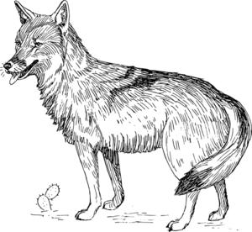
Central DeWitt County Wildlife
Management Association

2020-2021 COYOTE CONTEST

(Jan 6, 2020 thru January 05, 2021)
❖ No Entry Fee! ❖
Open to any member or non-member

$$$ CASH PRIZES $$$
Heaviest Male Coyote - $100.00
2nd Heaviest Male Coyote - $50.00
Heaviest Female Coyote - $100.00
2nd Heaviest Female Coyote - $50.00
Most Coyotes Killed By an Individual - $100.00
2nd Most Coyotes Killed By an Individual - $50.00
Prizes given at the 2021 CDCWMA Awards Banquet

RULES

Coyotes must be killed in DeWitt County or its adjoining counties:
(Goliad, Gonzales, Karnes, Lavaca, and Victoria) by any Legal Means.
Hunters must have a valid Texas Hunting License.

Coyotes must be registered at any of the Following three official stations:
Apple Lumber Company in Yorktown ❖
DeWitt County Producers Association in Cuero ❖
Curtis Jacob in Hochheim ❖

Official registration of a Coyote will require the removal of a pair of ears from the carcass which will be retained at the station. (A pair of ears shall be joined by the scalp portion.) For weight class Coyotes, hunters shall have the weight and sex of the Coyote recorded by the station. Note: weight class registered Coyotes will also count towards “Most Killed”.

Stations will record the name of the hunter, the date registered, the sex and weight of the coyote if desired by the hunter. A receipt of the registered kill will be provided to the hunter by the official station which is marked “Central DeWitt County Wildlife Management Association Coyote Contest”.

Each hunter will be responsible for submitting the receipt of a registered kill issued by the official stations. Mail to CDCWMA @ P.O. Box 776 Cuero, Texas 77954 Postmarked on or before January 10, 2021. Failure to mail receipts of registered kills to the CDCWMA by the required date will disqualify your entry into the contest. All ties will be split between winners for the places tied. Example if you are tied for first, both 1st and 2nd place prizes are combined and each winner receives half. Second place ties, each hunter tied will receive that prize divided by the number of hunters.

www.cdcwma.com

